**Problem 1**

1. **Formulate MIP:**
2. **Please refer to the R file “A1_Problem1.R”**

**Problem 2**

1. **Formulate MIP:**

Indices:

$k=index of facilities ∀k=1,2,3$

$l=index of customers ∀i=1,2,3,4,5$

Variables:

$x_{kl}=\left\{\begin{matrix}1 if facility k provide services to customer l \\ 0 otherwise \end{matrix}\right.$

Parameters:

$P_{kl}=distance betwee facility k and customer l$

(Euclidean distances between the coordinates of facility k and customer l)

$D_{l}=demand of customer l$

(These values were not used, since the threshold of how much each facility can supply was not given)

Formulation:

$$\min{\sum_{k=1}^{3}{\sum_{l=1}^{5}{{P_{kl}x}_{kl}}} }$$

$$\begin{matrix}s.t. & \sum_{k=1}^{3}{x_{kl}}=1 ∀l\end{matrix}$$

$$\begin{matrix} & x_{kl} ∈\end{matrix} \left\{0,1\right\}$$

1. **Please refer to the R file “A1_Problem2.R”**

**Problem 3**

1. **Formulate MIP (General):**

Indices:

$k=index of towers ∀k=1,2,3…n$

$c=index of customers ∀c=1,2,3…n$

Variables:

$y_{k}=\left\{\begin{matrix}1 if tower k is activated \\ 0 otherwise \end{matrix}\right.$

$$x_{kc}=\left\{\begin{matrix}1 if tower k reaches customer c \\ 0 otherwise \end{matrix}\right.$$

Parameters:

$P_{kc}=Signal strenght between tower k and customer c$

$P_{min}=Minimun signal strengh required for a connection$

Formulation:

$$\min{\sum_{k=1}^{n}{y_{k}} }$$

$$\begin{matrix}s.t. & {P_{min}x}_{kc}≤P_{kc} ∀k,c\end{matrix}$$

$$\begin{matrix} & \sum_{k}^{n}{x_{kc}}≥1 ∀c\end{matrix}$$

$$\begin{matrix} & My_{k}≥ \sum_{c}^{n}{x_{kc}} ∀k\end{matrix}$$

$$\begin{matrix} & x_{kc} ∈\end{matrix} \left\{0,1\right\}$$

$$\begin{matrix} & x_{k} ∈\end{matrix} \left\{0,1\right\}$$

1. **Example:**

Indices:

$k=1,2,3,4$

$c=1,2,3,4,5,6,7,8,9,10$

Parameters:

|  |  |  |  |  |  |  |  |  |  |  |
| --- | --- | --- | --- | --- | --- | --- | --- | --- | --- | --- |
| ***k\c*** | ***1*** | ***2*** | ***3*** | ***4*** | ***5*** | ***6*** | ***7*** | ***8*** | ***9*** | ***10*** |
| ***1*** | 8 | 28 | 9 | 23 | 16 | 3 | 13 | 19 | 16 | 23 |
| ***2*** | 17 | 20 | 23 | 8 | 11 | 16 | 2 | 7 | 29 | 4 |
| ***3*** | 14 | 15 | 26 | 9 | 14 | 16 | 16 | 5 | 1 | 3 |
| ***4*** | 17 | 13 | 24 | 24 | 14 | 25 | 11 | 2 | 0 | 0 |

$P_{kc}=$

$$P_{min}=10$$

Result:

$y_{1}=1; y_{2}=0; y_{3}=0; y_{4}=1$

1. **Please refer to the R file “A1_Problem3.R”**

**Problem 4**

1. **Formulate TSP:**

Indices:

$i=index of cities ∀i=1,2,3,4,5,6,7$

$j=alias of i$

Variables:

$x_{ij}=\left\{\begin{matrix}1 if the team travels directly from city i to city j \\ 0 otherwise \end{matrix}\right.$

Parameters:

$C_{ij}=travel time between each city in minutes$

(For Cij where i = j, a big M value of 10,000 was given)

Formulation:

$$\min{\sum_{i=1}^{7}{\sum_{j=1, j≠i}^{7}{{C_{ij}x}_{ij}}} }$$

$$\begin{matrix}s.t. & \sum_{i=1, i≠j}^{7}{x_{ij}}=1 ∀j\end{matrix}$$

$$\begin{matrix} & \sum_{j=1, j≠i}^{7}{x_{ij}}=1 ∀i\end{matrix}$$

$$\begin{matrix} & u_{1}=1\end{matrix}$$

$$\begin{matrix} & 2 ≤u_{i}≤7\end{matrix} ∀i≠1$$

$$\begin{matrix} & u_{i}- u_{j}+1≤(7-1)\end{matrix} (1-x_{ij} ) ∀i≠1, j≠1$$

$$\begin{matrix} & x_{ij} ∈\end{matrix} \left\{0,1\right\}$$

1. **Please refer to the R file “A1_Problem4.R”**

**Bonus**

N=3

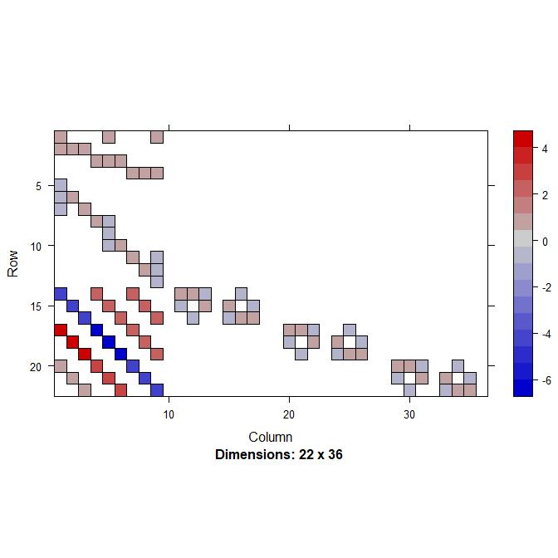

N=5

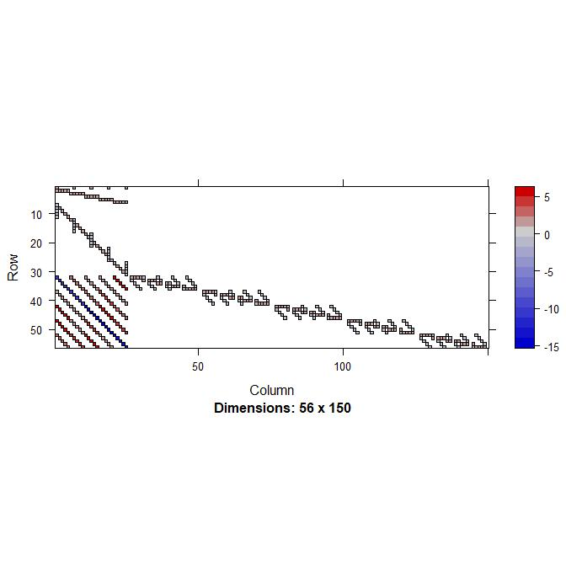

N=10

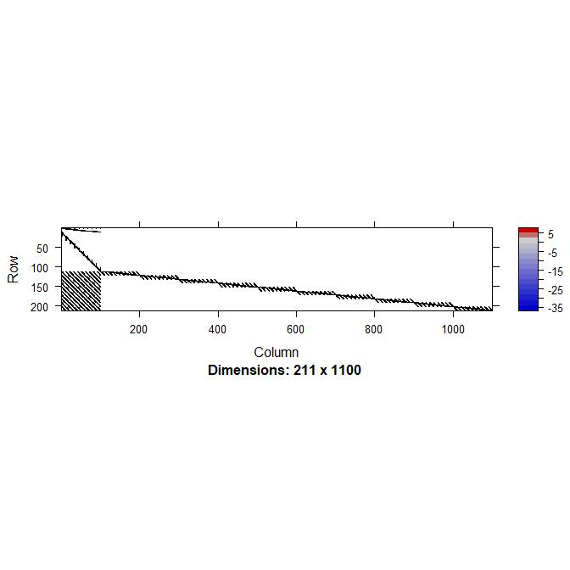

For the R code please refer to the R file “A1_Bonus.R”